STATE OF INDIANA)
SS)
COUNTY OF CLAY)

The October 2, 2023, regular meeting of the Clay County Council was called to order by Vice President Jason Thomas at 6:00 p.m. Council members present were Jason Thomas, John Nicoson, Dave Amerman, Jackie Mitchell, Jason Britton, and Pat Heffner. Larry Moss was not present. Auditor Patricia Foxx made a record of the proceedings to wit:

Dave Amerman led the Pledge of Allegiance followed by the opening prayer by Jason Britton.

A motion to approve the September 5, 2023, Regular Meeting and September 11, 2023 Special Meeting minutes was made by Jackie Mitchell and seconded by Dave Amerman. Motion carried 6-0.

IN THE MATTER OF ADDITIONAL APPROPRIATIONS

Jason Thomas read the following:

COUNTY EMERGENCY APPROPRIATION ORDINANCE

Whereas, It has been determined that it is now necessary to appropriate more money than was appropriated in the annual budget; now, therefore:

Sec.1. Be It Ordained by the County Council of Clay County, Indiana, that for the expenses of the taxing unit the following additional sums of money are hereby appropriated out of the funds names and for the purposes specified, subject to the laws governing the same:

Aye Nay

COUNTY GENERAL Request

Other Services & Charges $ 56,000.00 ___6_ _

COUNTY PUBLIC SAFETY LOIT
Other Services & Charges $ 15,000.00 ___6___ _____

STATEWIDE 911
Other Services & Charges $ 5,000.00 ___6___ _____

Presented to the Clay County Council, read in full and adopted this 2nd day of October, 2023.

AYE NAY
_____________ ______

Jason Thomas /s/__________________ ___________________________

Jackie Mitchell /s/ ___ ______

Jason Britton /s/ _______

John Nicoson /s/ ______ ______

Dave Amerman /s/ ______ ____

Pat Heffner /s/ ______ ______
Members of the Clay County Council

ATTEST: __Patricia A Foxx /s/
Patricia A Foxx, Clay County Auditor

Marty Heffner, Commissioner, explained the appropriations of $40,000.00 was to cover the jail boiler repairs at the Sheriff Department. The $10,000.00 is for the cost of the attorney fees. The $1,000.00 is for the legal notices for the newspaper. The $5,000.00 is for the increase of the tax sale cost.

Motion was made to approve the $56,000.00 by Jackie Mitchell and seconded by John Nicoson. Motion carried 6-0.

Brison Swearingen, Sheriff, explained the $15,000 was for the unforeseen repairs on vehicle fleet. The Statewide E-911 appropriation of $5,000.00 was for the Software Interface Installation for CAD to CAD interface with other counties in case of emergency/natural disaster.

Motion was made to approve the $20,000.00 by Jackie Mitchell and seconded by John Nicoson. Motion carried 6-0.

IN THE MATTER OF TRANSFER

There were none presented.

IN THE MATTER OF AMENDED SALARY ORDINANCE

ORDINANCE 2023-16

AMENDED SALARY ORDINANCE

An ordinance setting compensation for certain County Employees, for the fiscal year 2023.

Be it ordained by the County Council of Clay County, Indiana as follows:

COUNTY GENERAL

SHERIFF

Sheriff Full Time Clerical $22.90 Per Hour Full Time (1)Non Exempt
PT Civil Process Server $16.66 Per Hour
PT Courthouse Security $16.66 Per Hour

JAIL
Matron $24.26 Per Hour Full Time (1)Non Exempt
Matron Overtime $36.39 Per Hour
Jail Commander $22.14 Per Hour Full Time (1)Exempt Plus
Jail Commander Overtime $33.21 Per Hour
Assistant Jail Commander $21.48 Per Hour Full Time (2)Non Exempt
Assistant Jail Comm OT $32.22 Per Hour
Jail Shift Supervisor $19.89 Per Hour Full Time (4)Non Exempt
Jail Shift Supervisor OT $29.84 Per Hour
Jail ICE Shift Supervisor $19.89 Per Hour Full Time (1)Non Exempt
Jail ICE Shift Supervisor OT $29.84 Per Hour
Jail Officers $19.74 Per Hour Full Time (38)Non Exempt
Jail Officers Overtime $29.61 Per Hour
PT Video Visit Officer $16.66 Per Hour Part Time

STATEWIDE 911
Chief Dispatcher/Coordinator $23.28 Per Hour Full Time (1)Non Exempt
Chief Dispatcher/Coordinator OT $34.92 Per Hour
Assist Supervisor Dispatcher $21.36 Per Hour Full Time (1)Non Exempt
Assist Supervisor Dispatcher OT $31.76 Per Hour
Night Shift Supervisor $21.36 Per Hour Full Time (2)Non Exempt
Night Shift Supervisor OT $31.76 Per Hour
Dispatcher $21.17 Per Hour Full Time (11)Non Exempt
Dispatcher Overtime $31.76 Per Hour

Effective October 13, 2023. Presented to the Clay County Council this 2nd day of October, 2023. Approved by the following aye and nay vote.

AYE NAY

____________________________ ________ _____

Jason Thomas /s/__________________ __________________________

Jackie Mitchell /s/ _ _ ___ _____

Jason Britton ____ ____

John Nicoson /s/ ____ ______

Dave Amerman /s/ ______

Pat Heffner /s/ _____ ______
Members of the Clay County Council

ATTEST: Patricia A Foxx /s/
Patricia A Foxx, Clay County Auditor

Brison Swearingen, Sheriff, explained that he had enough funds in his budget to adjust the salaries that are listed in the Salary Ordinance 2023-16. His departments would be getting the raises effective October 13, 2023 of the pay week instead of the first of the year.

Motion to approve Ordinance 2023-16 as presented was made by Jason Britton and seconded by John Nicoson. Motion carried 6-0.

IN THE MATTER OF THE FINAL ACTION FOR EMMERT GROUP LLC TAX ABATEMENT

Attorney Traci Orman, appeared before the Council on behalf of the above listed company and presented the First Reading of the following:

RESOLUTION NO. 2023-_14_

A Resolution of the County Council of
Clay County, Indiana, Designating an Area Within
Clay County, Indiana as an Economic Revitalization Area
for the Purpose of a Ten (10) Year Real Property Tax Abatement

WHEREAS, a Petition for a ten (10) year real property tax abatement has been filed with the County Council of Clay County, Indiana (hereinafter “County Council”) requesting that the property described therein be designated as Economic Revitalization Area for purposes of real property tax abatement; and

WHEREAS, Emmert Group Properties, LLC (hereinafter the "petitioner,") has submitted a Statement of Benefits and provided all information and documentation necessary for the County Council to make an informed decision, said information including a description of the real property which is more particularly described in Exhibit A.

WHEREAS, petitioner has represented and presented evidence that in connection with the Project, both the real property improvements and the addition of new equipment. Petitioner represents that it currently has an existing 75_ full-time hourly and salaried jobs with an annual payroll of $3,020,680.00. Completion of this project will create approximately 6 new permanent full-time hourly jobs with a total annual payroll of approximately $226,640.00. Petitioner has further represented and presented evidence that the cost of this project will be approximately $250,000.00 for real property improvements and approximately $791,200.00 for new equipment (the "manufacturing equipment").

WHEREAS, the County Council is authorized under the provisions of I.C. 6-1.1-12.1-1 et. seq. to designate areas of the County as economic revitalization areas for the purpose of tax abatement; and

WHEREAS, the County Council has considered the petition and Statement of Benefits and has conducted a complete and proper investigation of the subject property and neighborhood to determine that the area qualifies as an economic revitalization area under Indiana statutes; and

WHEREAS, the County Council has found the subject property to be an area where facilities that are technologically, economically, or energy obsolete are located and where the obsolescence may lead to a decline in employment and tax revenues and has become undesirable for or impossible of normal development and occupancy because of a lack of development, cessation of growth, deterioration of improvements, character of occupancy, age, obsolescence, substandard buildings and other factors which prevent normal development or use.

NOW, THEREFORE, IT IS FOUND, DETERMINED AND RESOLVED by the County Council of Clay County, Indiana that:

1. The petitioner's estimate of the value of the redevelopment and rehabilitation and the project to be constructed on the subject real property is reasonable for projects of that nature in order to maintain, expand, update and improve opportunities and capacity for manufacturing.

2. The petitioner's estimate of the number of individuals who will be employed and retained, and the benefit thereby, can reasonably be expected to result from the project and the redevelopment and rehabilitation.

3. The petitioner's estimate of the annual salaries or wages of the individuals who will be employed and retained, and the benefit thereby, can reasonably be expected to result from the project and the redevelopment and rehabilitation.

4. That the other benefits about which information has been requested can be expected to result from the project and the redevelopment and rehabilitation.

5. The totality of the benefits of the proposed redevelopment and rehabilitation can reasonably be expected to result from the project and are sufficient to justify a ten (10) year real property tax deduction from assessed valuation under Indiana statutes, in accord with the attached Deduction Schedule and each such deduction should be, and they are hereby, allowed.

6. Based upon: (1) the Petitioner’s total investment in real property; (2) the number of new full-time equivalent jobs created or retained; (3) the average wage of the new employees compared to the State minimum wage; and (4) the infrastructure requirements for Petitioner’s investment and the County Council has found that the totality of the benefits of the proposed project
are sufficient to justify real property tax abatement over a ten (10) year deduction period, in accord with the attached Deduction Schedule and each such deduction should be, and they are hereby, allowed in accord with the attached Abatement Schedule.

7. That the petition for designating the subject property as an economic revitalization area for the purposes of a ten (10) year real property tax abatement and the Statement of Benefits copies of which were submitted with the petitions are hereby approved and the Real Estate described hereinabove is hereby designated as an Economic Revitalization Area pursuant to I.C. 6-1.1-12.1-1 et. seq., and petitioner is entitled to the ten (10) year real property tax abatement pursuant to the following ten (10) year abatement deduction schedule which the County Council hereby establishes, prescribes, and adopts: SEE EXHIBIT B ATTACHED HERETO, for the proposed redevelopment and rehabilitation.

8. That notice hereof should be published according to law stating the adoption and substance hereof, that a copy of the description of the affected area is available for inspection in the County Assessor's Office and stating a date on which the County Council will hear and receive remonstrances and objections and take final action, all as required by law.

9. That this Resolution is supplementary to and in addition to any prior resolutions.

10. That this abatement is subject to the terms and provisions of the Abatement Calculation Agreement entered by and between the County Council of Clay County, Indiana and Petitioner pursuant to I.C. 6-1.1-12.1-2(i).

11. Pursuant to I.C. 6-1.1-12.1-14, the County Council of Clay County, Indiana, has, pursuant to Resolution 6-2008, established an Abatement Fee, Petitioner has been advised of said fee and agreed to the imposition of the Abatement Fee and incorporation of that fee in the initial Resolution approving the Abatement. Now, therefore, the County Council of Clay County, Indiana, incorporates herein the provisions of I.C. 6-1.1-12.1-14 and declares that the percentage to be applied by the County Auditor for purposes of Step Two of I.C. 6-1.1-12.1-14(c) is 5%.

Passed in Open Council this __5___ day of September, 2023.

CLAY COUNTY COUNCIL

__Dave Amerman /s/ __
Dave Amerman

__Jason Thomas /s/_
Jason Thomas

____Jason Britton /s/__
Jason Britton

_Patricia Heffner /s/_
Patricia Heffner

_Jacqueline Mitchell /s/
Jacqueline Mitchell

_Larry J. Moss /s/__
Larry J. Moss

_John Nicoson /s/
John Nicoson
ATTEST:

Patricia Foxx /s/_______________
Patricia Foxx, Clay County Auditor

This instrument prepared by ______________________________________________________ Louis F. Britton, COX, ZWERNER, GAMBILL & SULLIVAN, LLP
511 Wabash Avenue, Terre Haute, IN 47807; (812) 232-6003.

IN THE MATTER OF CLERK’S OFFICE SCANNING UPDATE

Amy Jordan, Clerk, presented an update of the scanning project in her office. Her staff been scanning the files in the office. She has been getting quotes for the rest of the scanning and will present them to the Commissioners and Council next month.

IN THE MATTER OF HAVA ELECTION SECURITY LOCAL GRANT

Amy Jordan, Clerk, presented the HAVA Election Security Local Grant. The grant will be used for Voting Process Improvements and Votor/Poll Worker Outreach and Education.

Motion to approve the HAVA Election Security Local Grant as presented was made by Jackie Mitchell and seconded by Dave Amerman. Motion carried 6-0.

IN THE MATTER OF COMMUNITY CORRECTIONS ON CALL

Patti Foxx, Auditor, explained the on call for his employees will increase from $150.00 weekly to $200.00 weekly. Jordan does have funds in his budget for the increase.

Motion to approve the increase on call rate as presented was made by Pat Heffner and seconded by Jason Britton. Motion carried 6-0.

IN THE MATTER OF CASA GRANT RENEWAL

Sarah Tellechea, with CASA, presented the State Matching Grant and Capacity Building Grant for $27,140.00 (Matching Grant) and $11,637.00 (Capacity Building Grant). These are the same grants the County has had for several years. The grant is effective January 1, 2024 thru December 31, 2024. This a county matching grant with the match coming from salaries and office space.

Motion to approve the CASA grant as presented for 2024 was made by Dave Amerman and seconded by Jackie Mitchell. Motion carried 6-0.

IN THE MATTER OF CONSIDERATION OF 2024 HMEP GRANT

Rob Gambill, EMA Director, presented the 2024 HMEP grant for $7,495.00. Rob stated there is no county match grant and will start October 1, 2023 thru September 30, 2024. The grant will be used for LEPC to present three hazardous material response courses to local first responders.

Motion to approve the 2024 HMEP Grant as presented was made by Dave Amerman and seconded by Pat Heffner. Motion carried 6-0.

IN THE MATTER OF CONSIDERATION OF EMPG SALARY GRANT

Rob Gambill, EMA Director, presented the 2023 EMPG Salary Grant for $22,600.00. Rob stated this is a county match grant and will start October 1, 2022 thru September 30, 2023. The maximum amount is $22,600.00 and is a county matching grant where half of the director’s salary is reimbursed.

Motion to approve the 2022 EMPG Salary Grant as presented was made by John Nicoson and seconded by Jason Britton. Motion carried 6-0.

IN THE MATTER OF CONSIDERATION OF ARPA FUNDING

Marty presented Resolution 2023-15 to the Clay County Council for the approval of the American Rescue Plan Act plan for the County. This is for the adoption of the ARP Plan for the County. The awarded amount of $5,093,899.00.
Motion to approve the Resolution 2023-15 as presented was made by Dave Amerman and seconded by Pat Heffner. Motion carried 6-0.

IN THE MATTER OF BUDGET ADOPTIONS

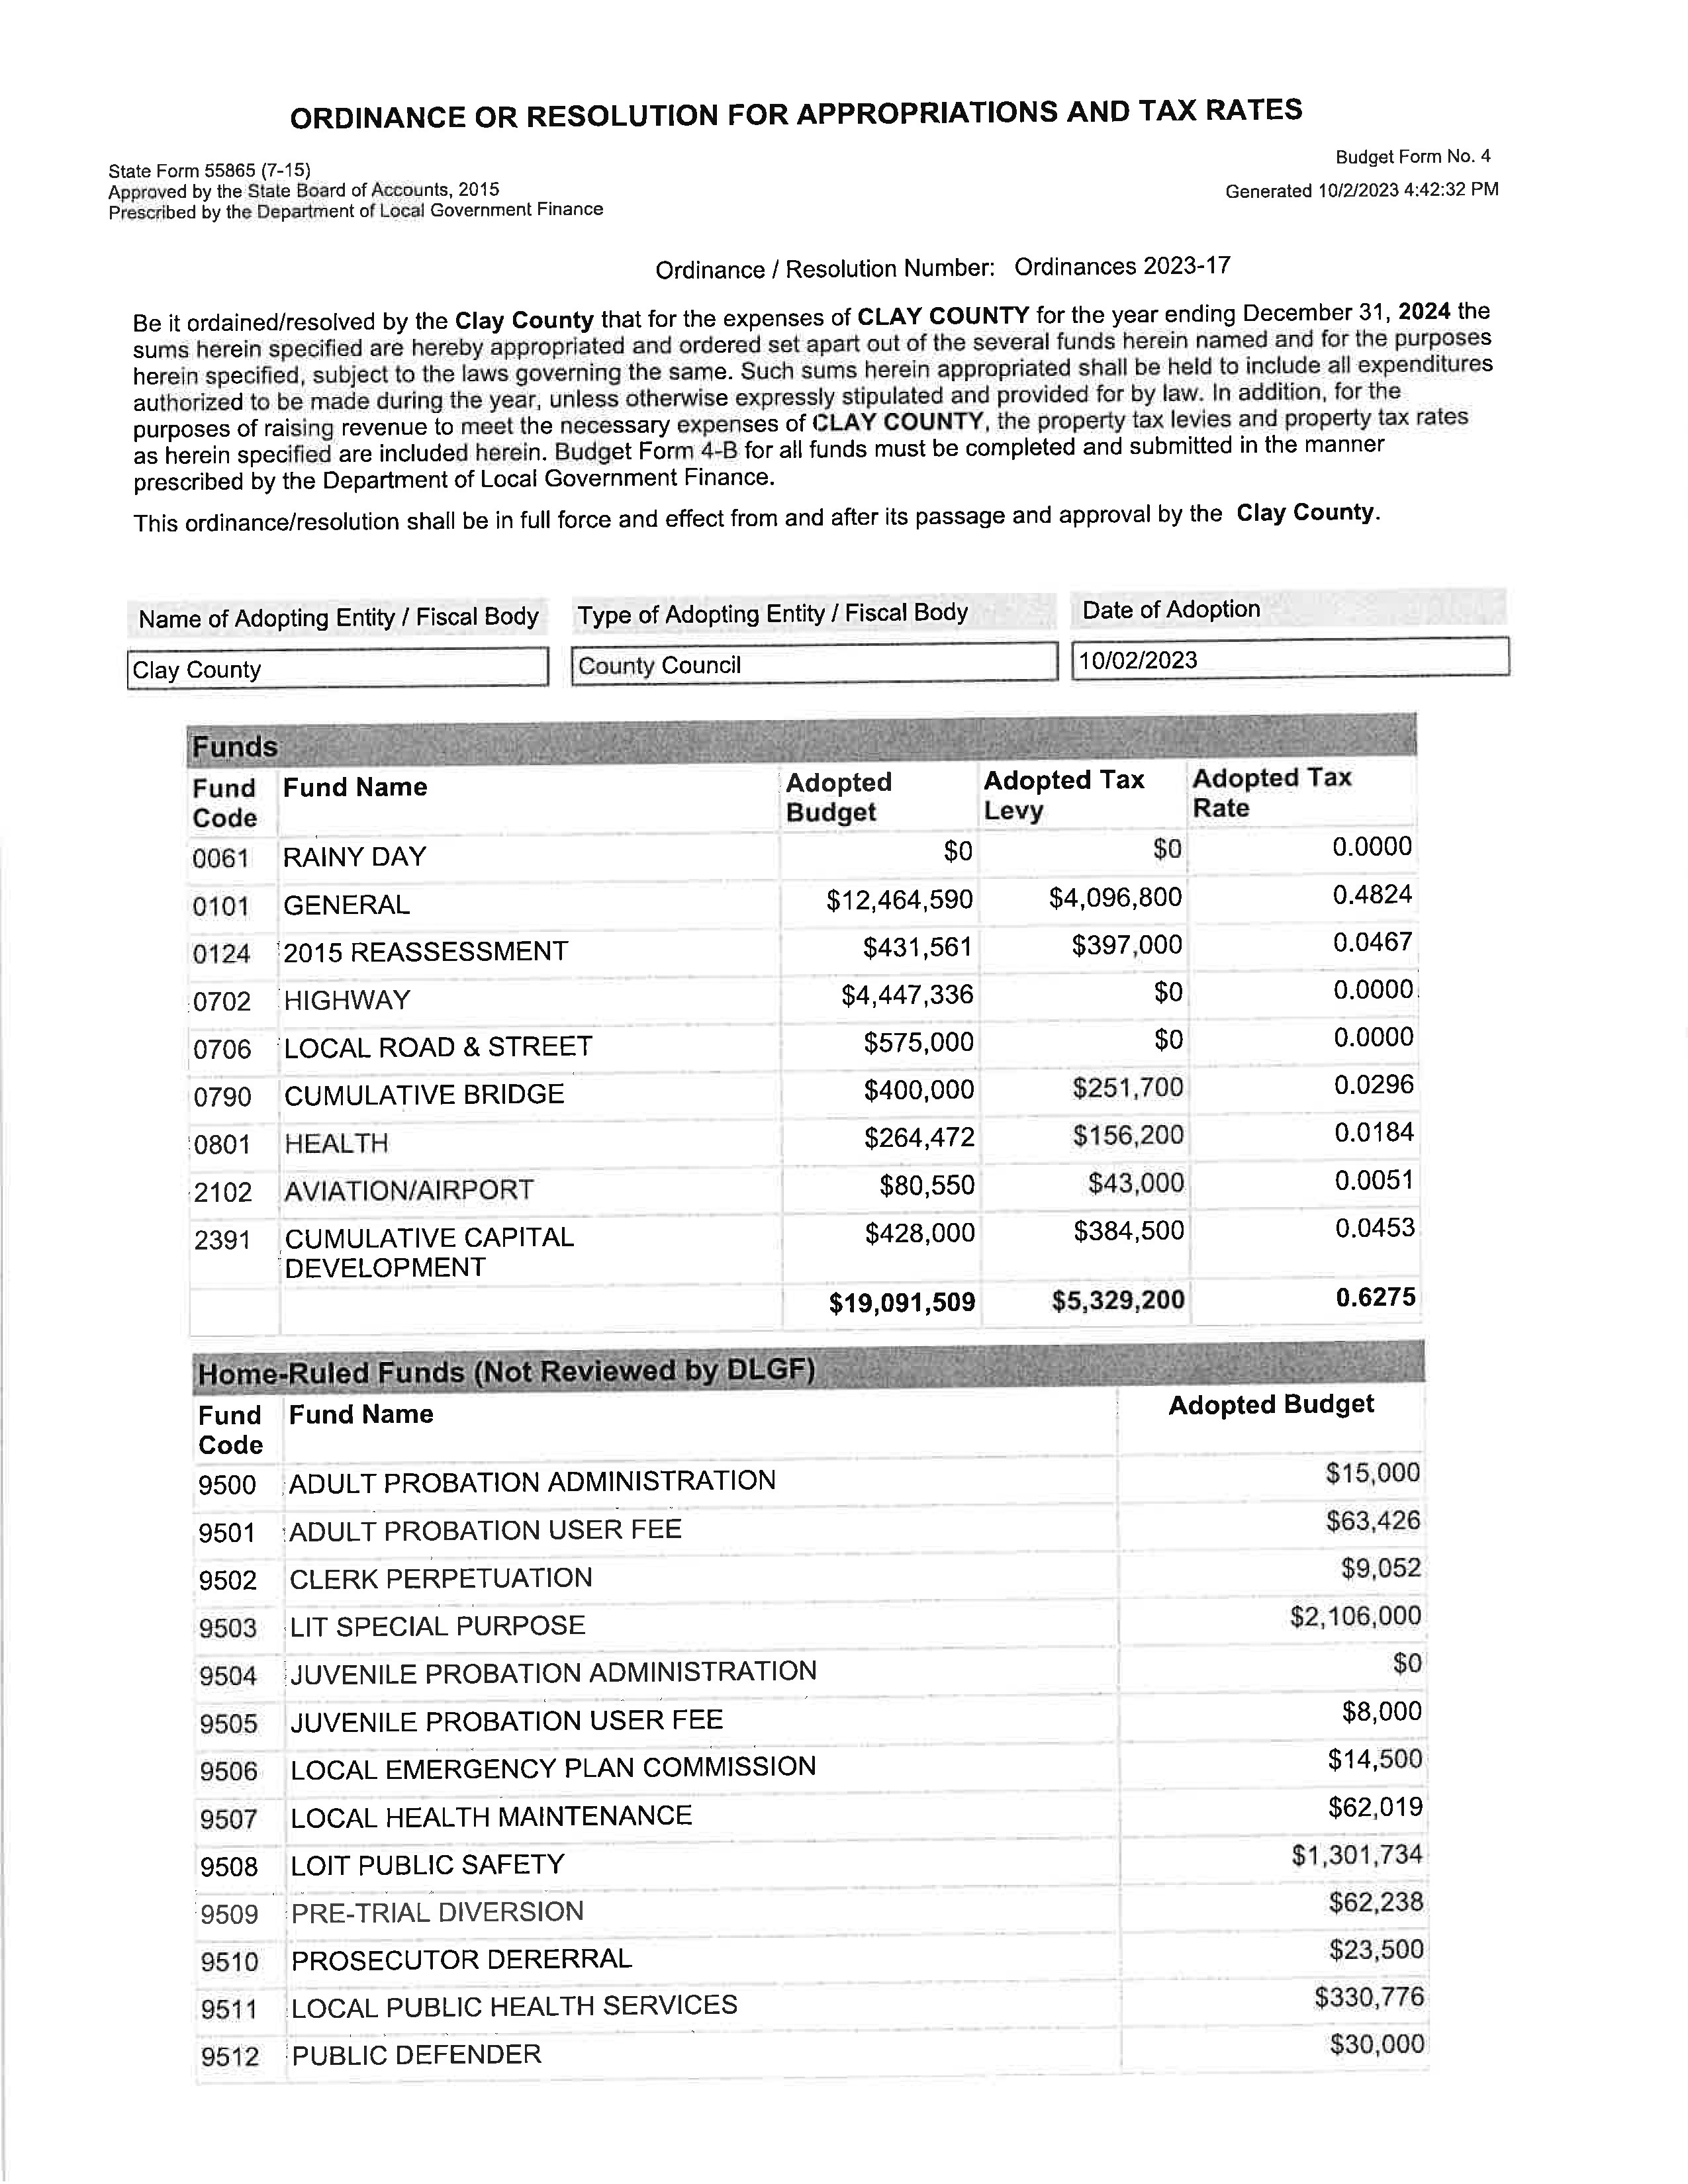
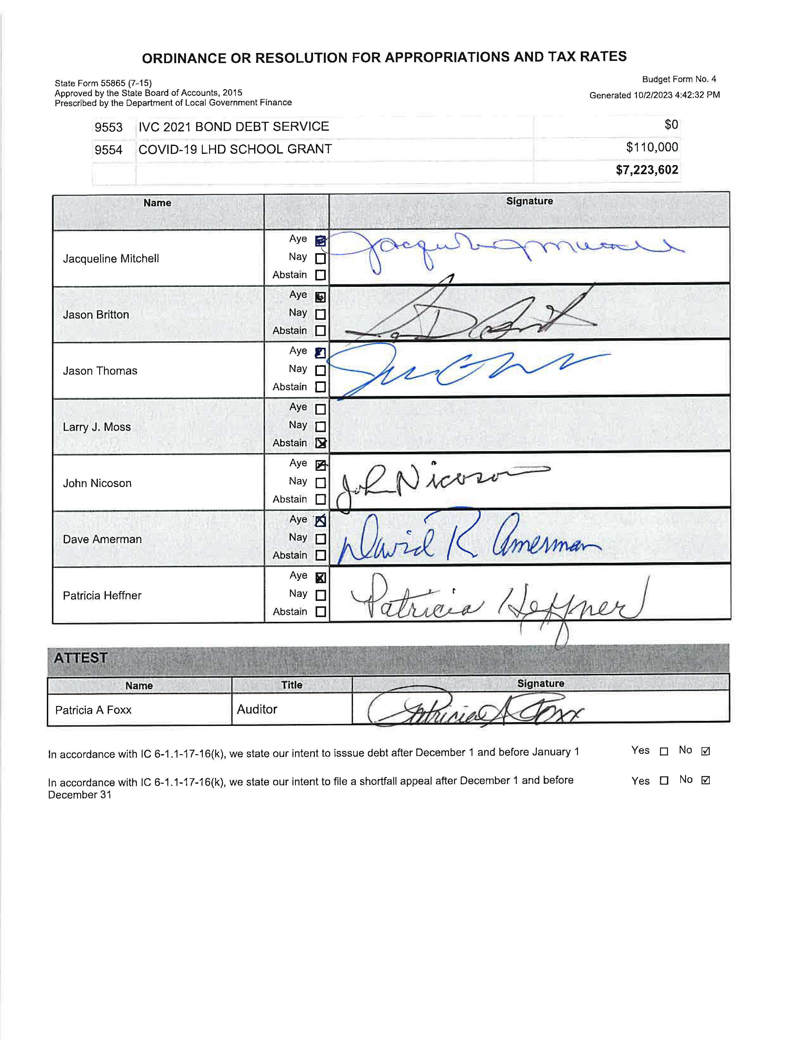
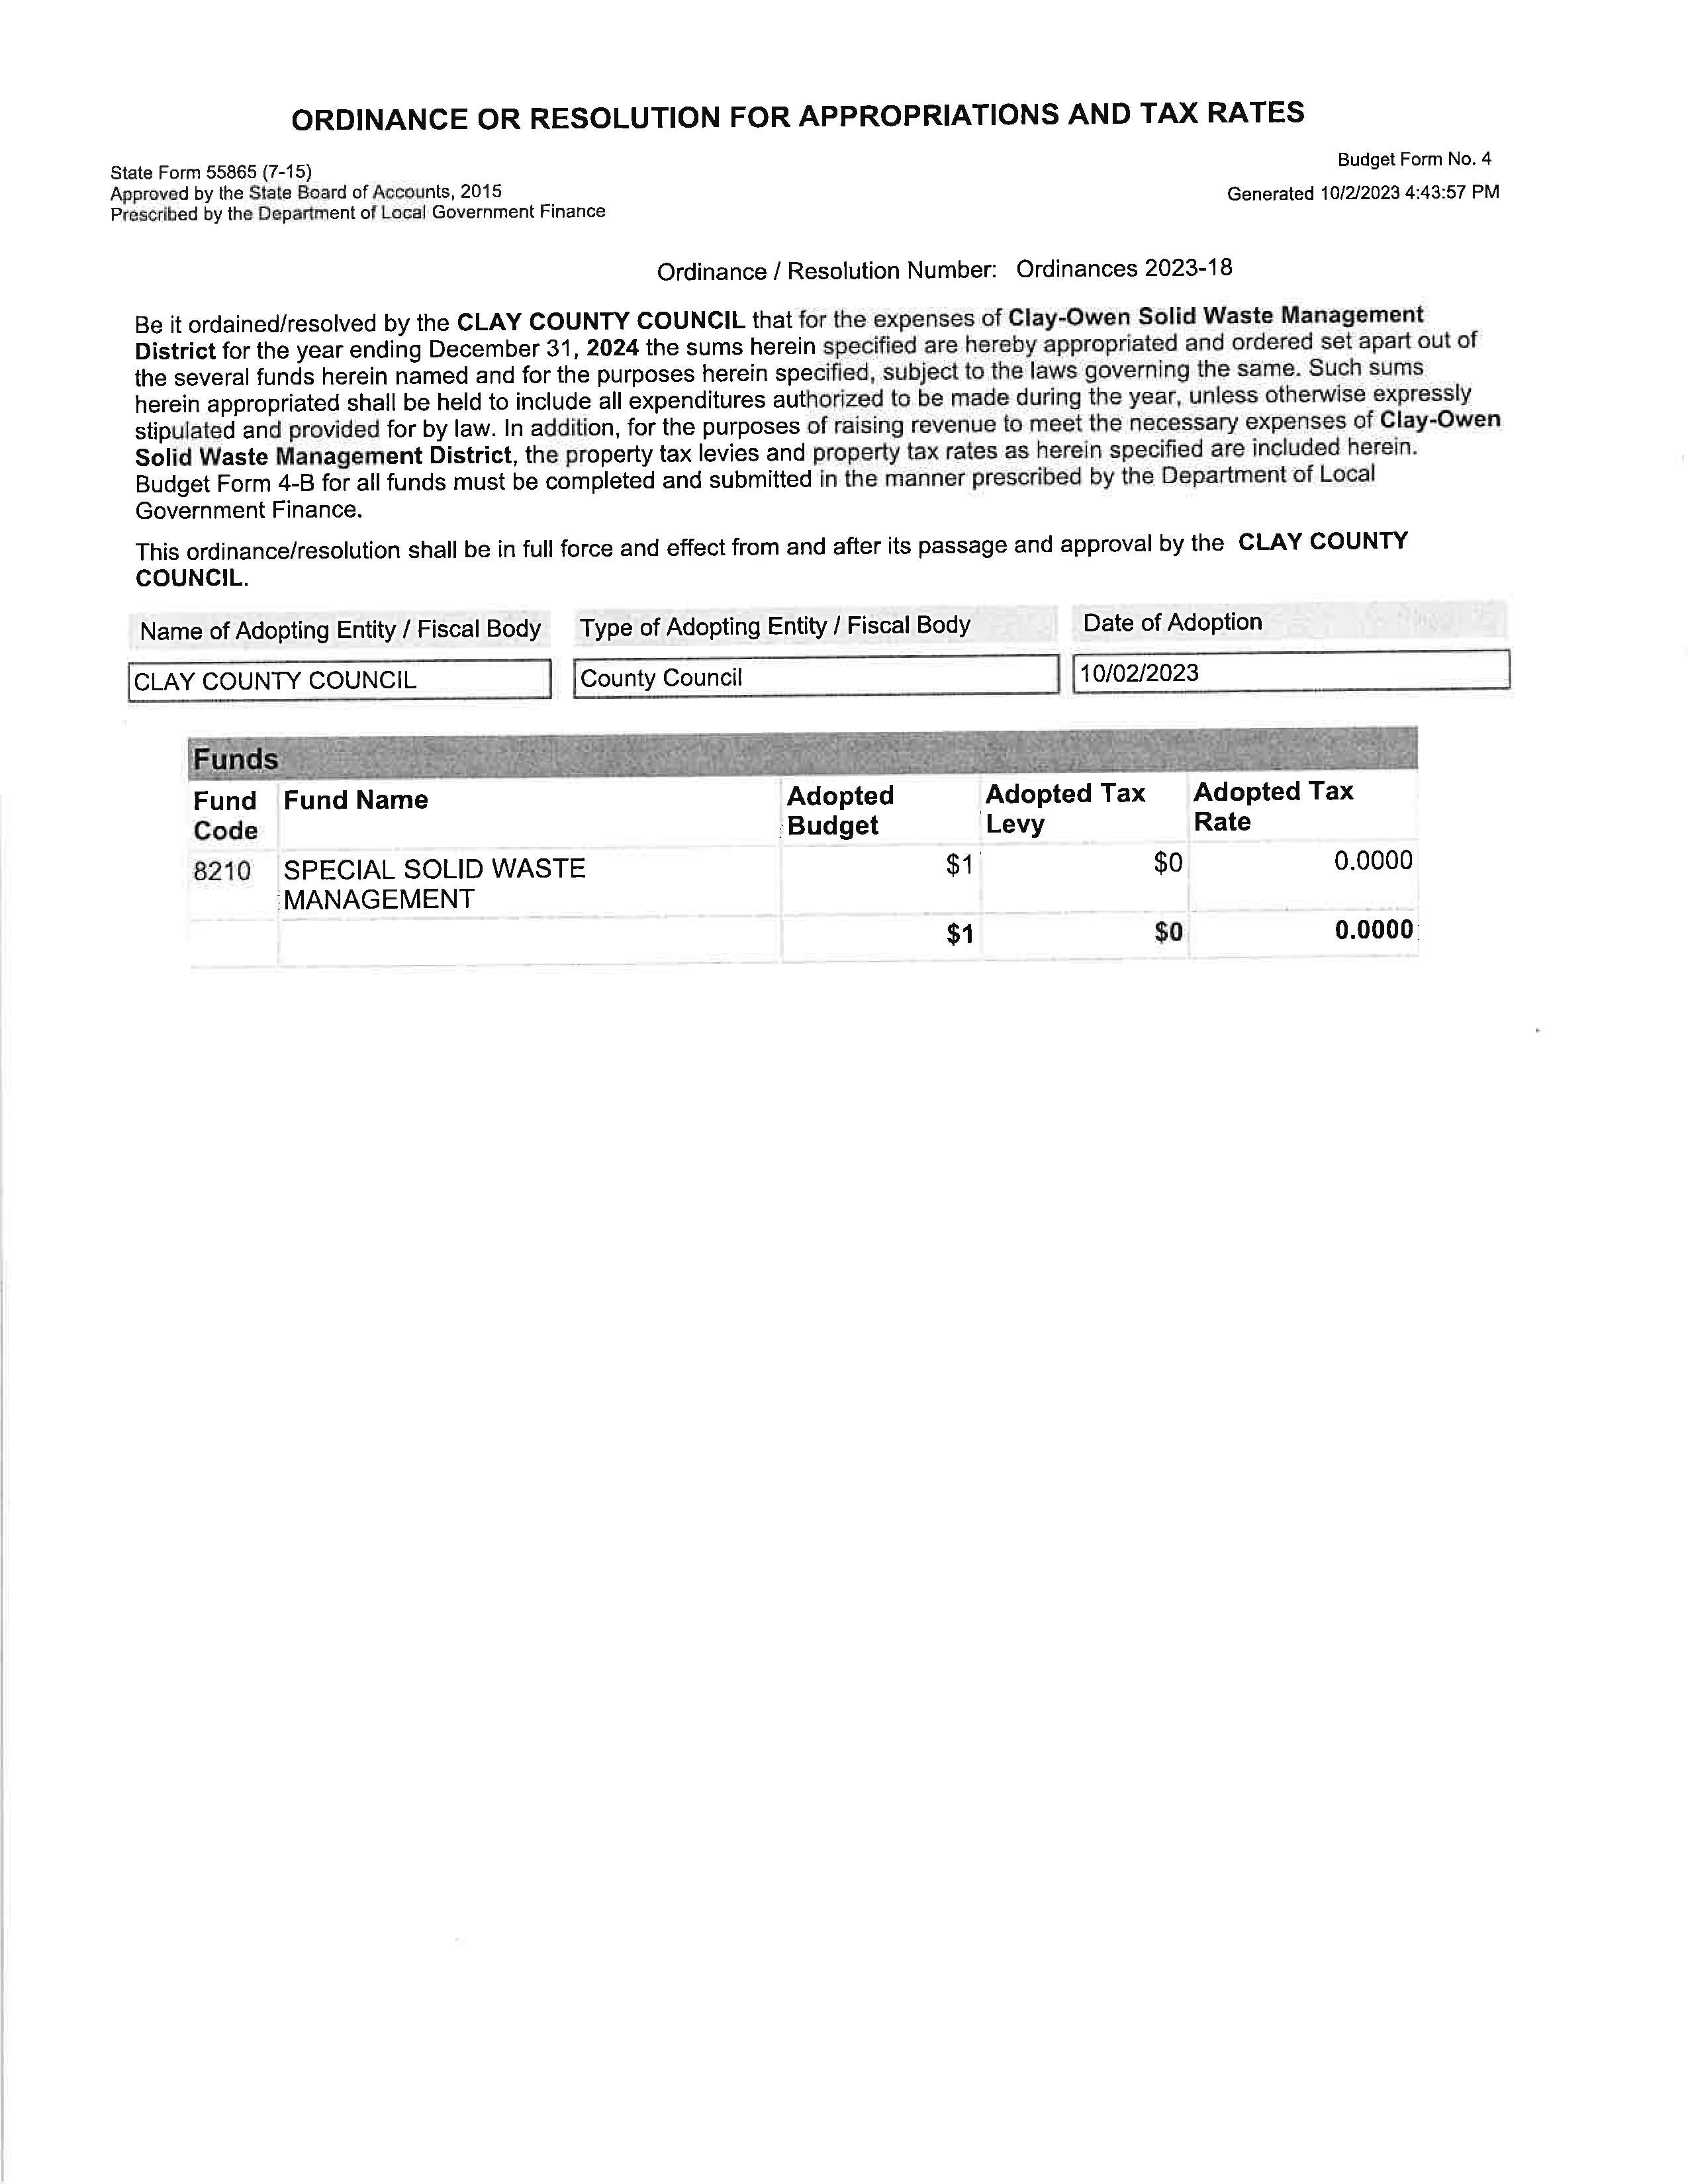
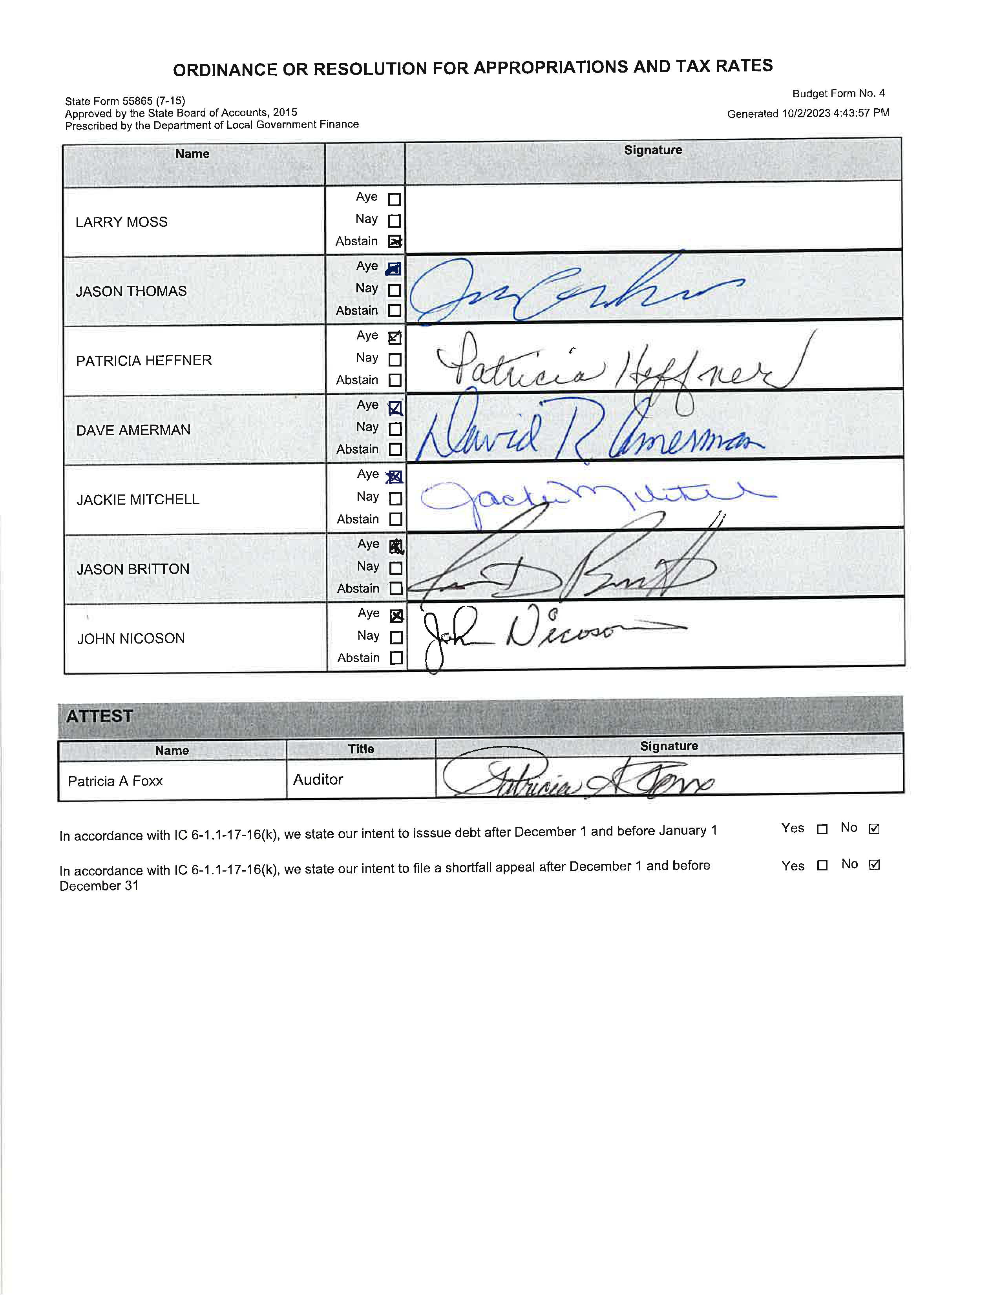
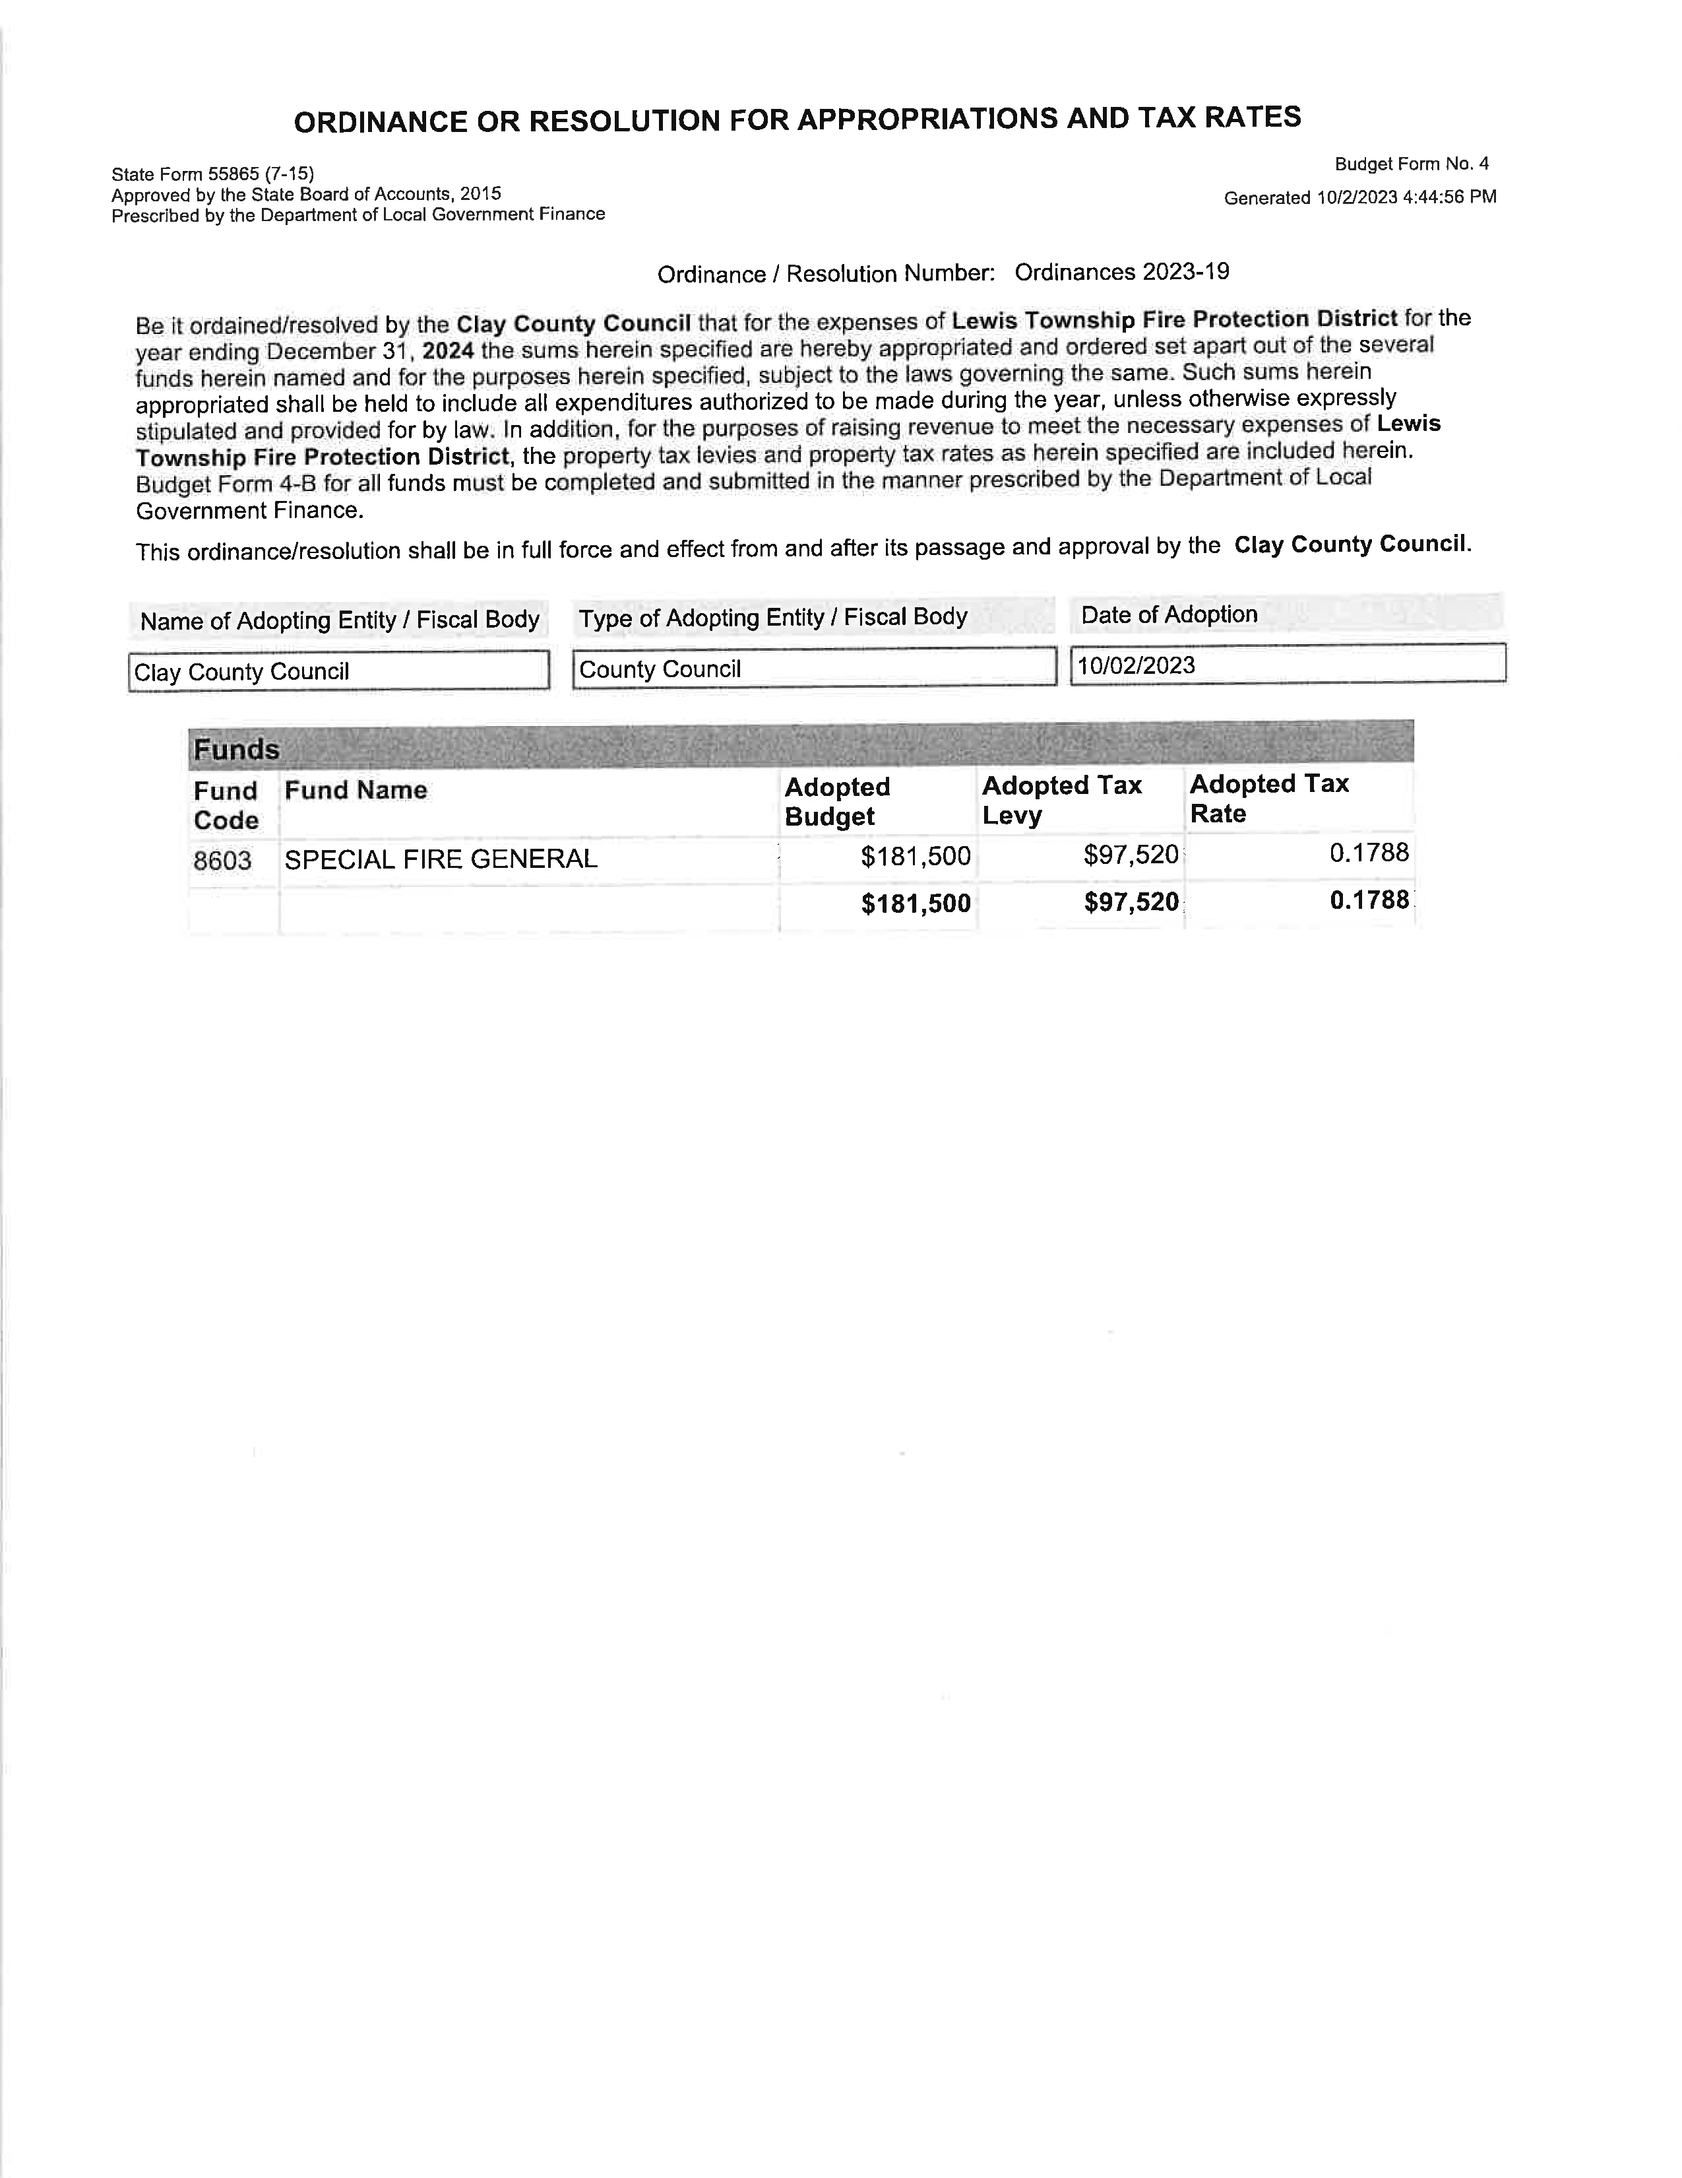
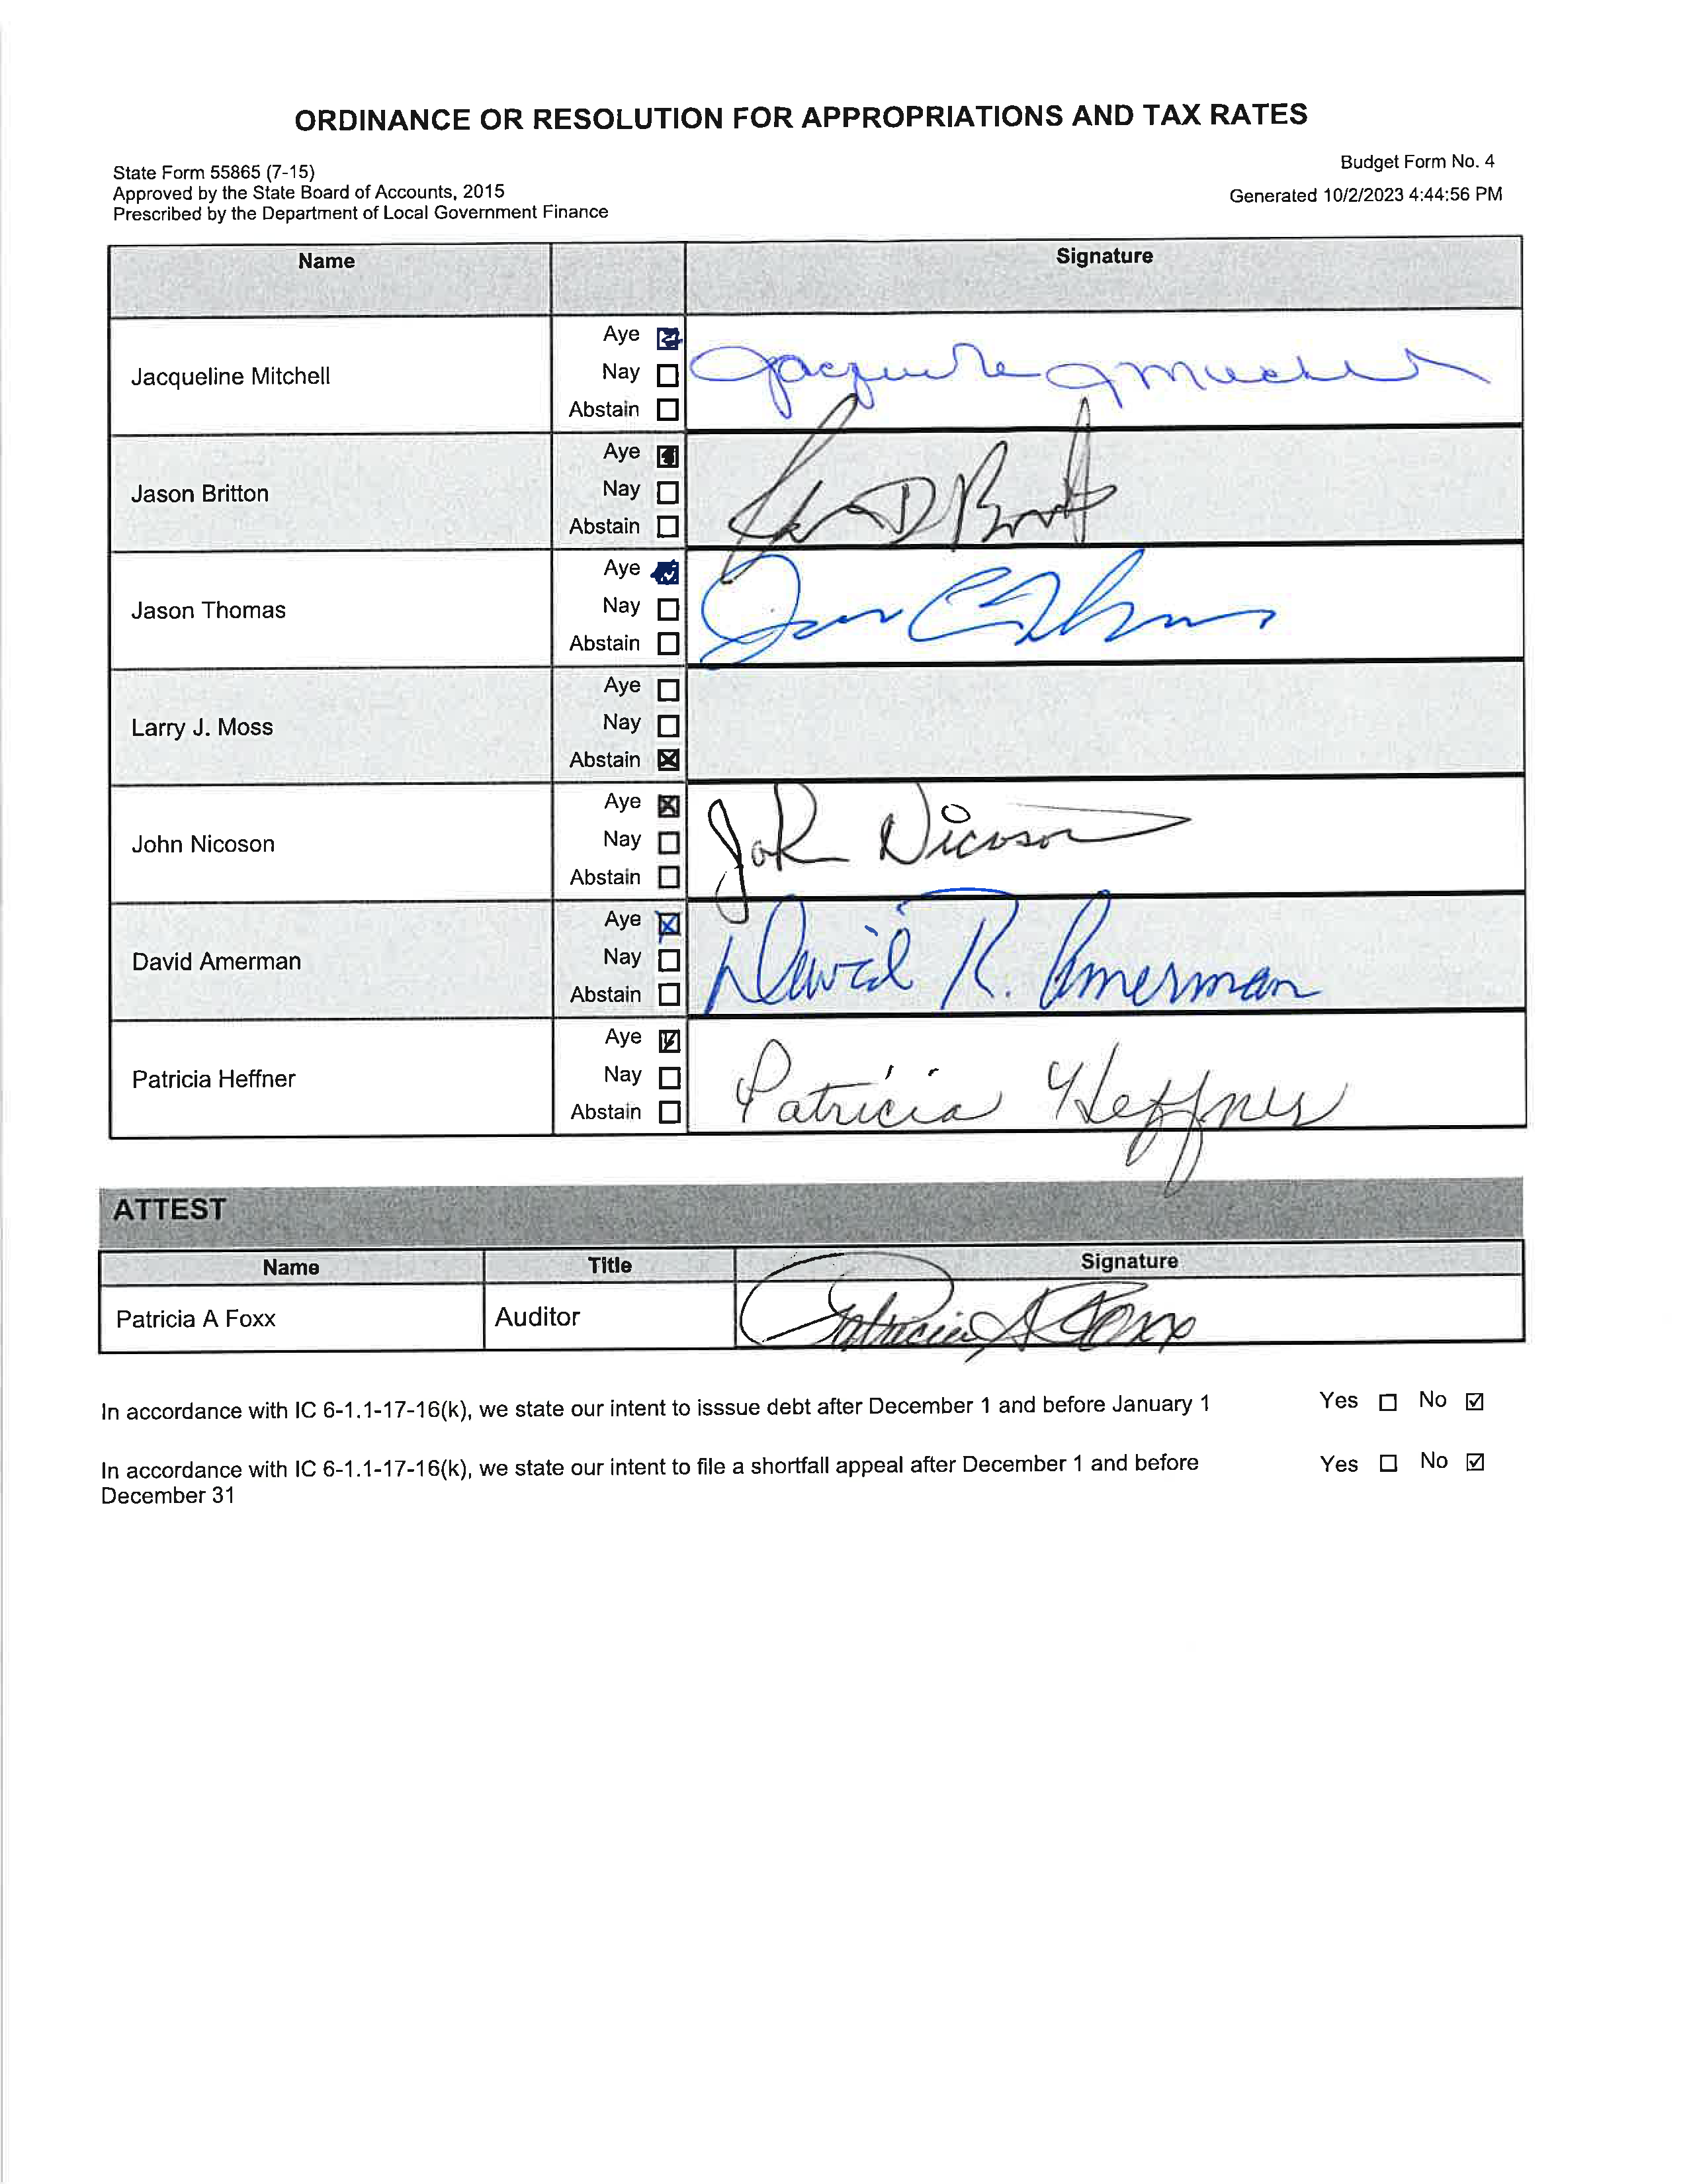
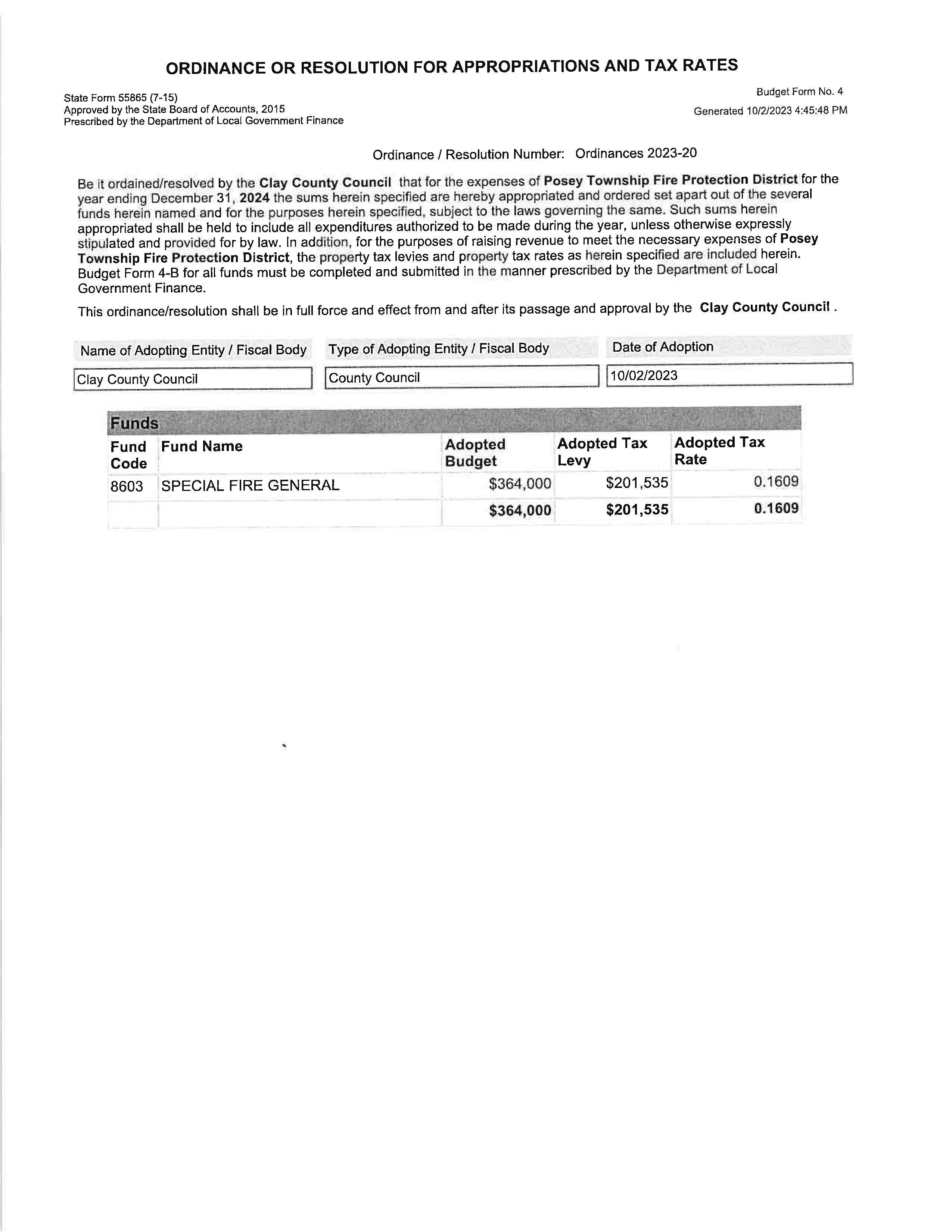

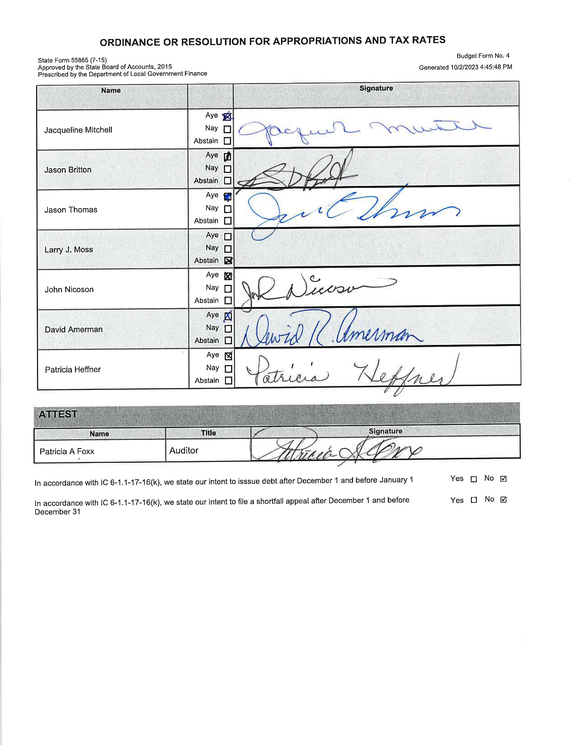
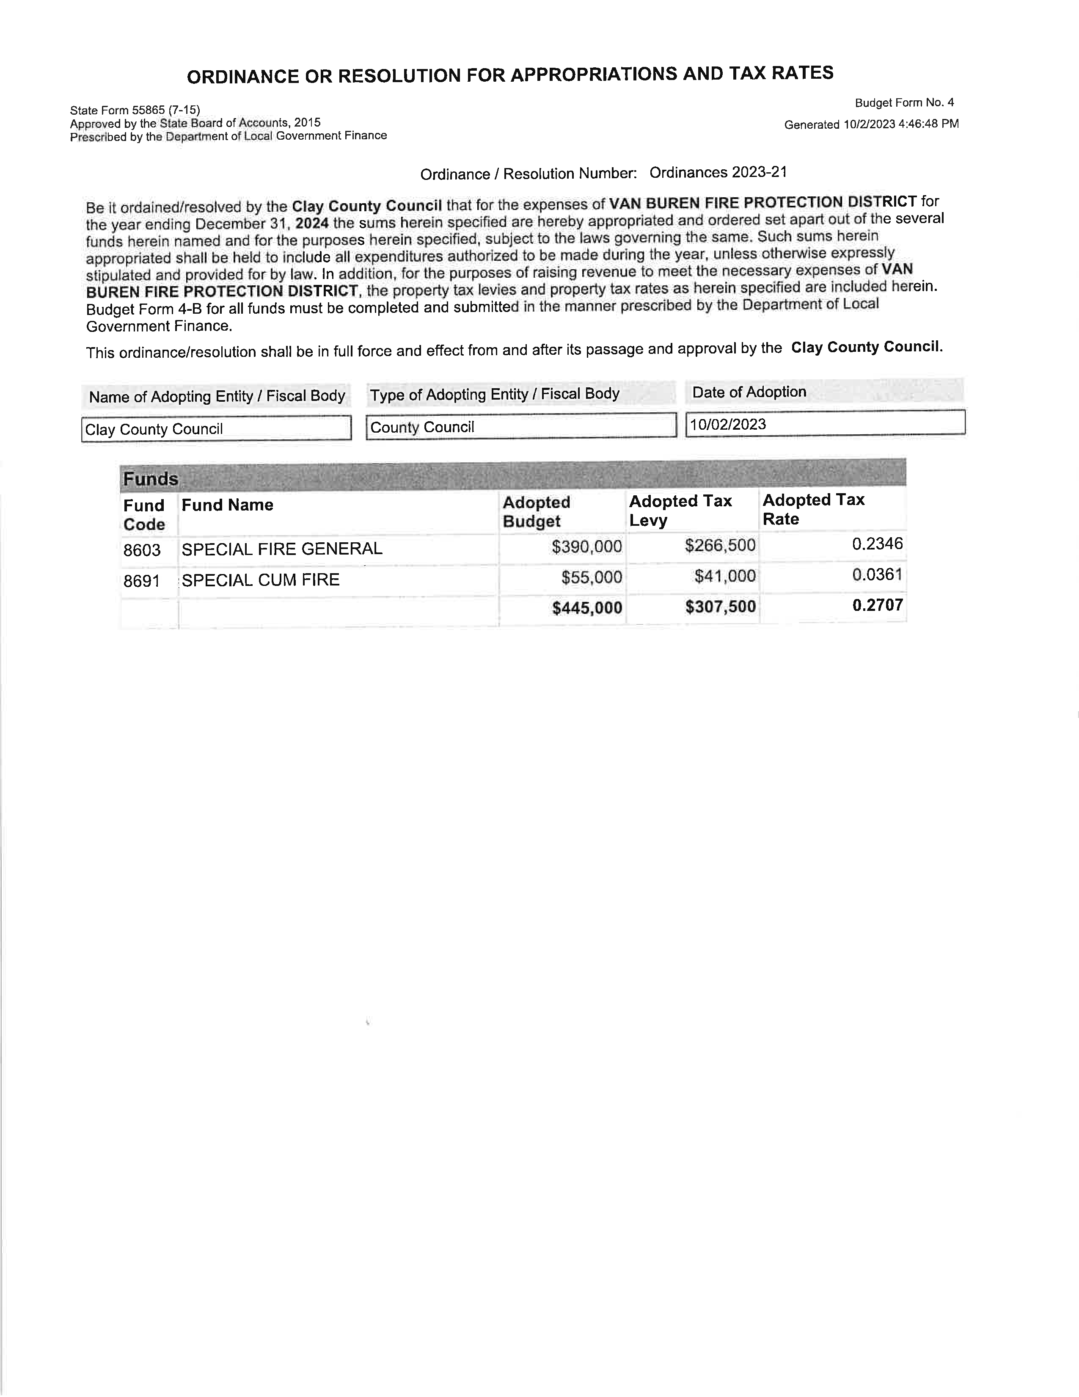

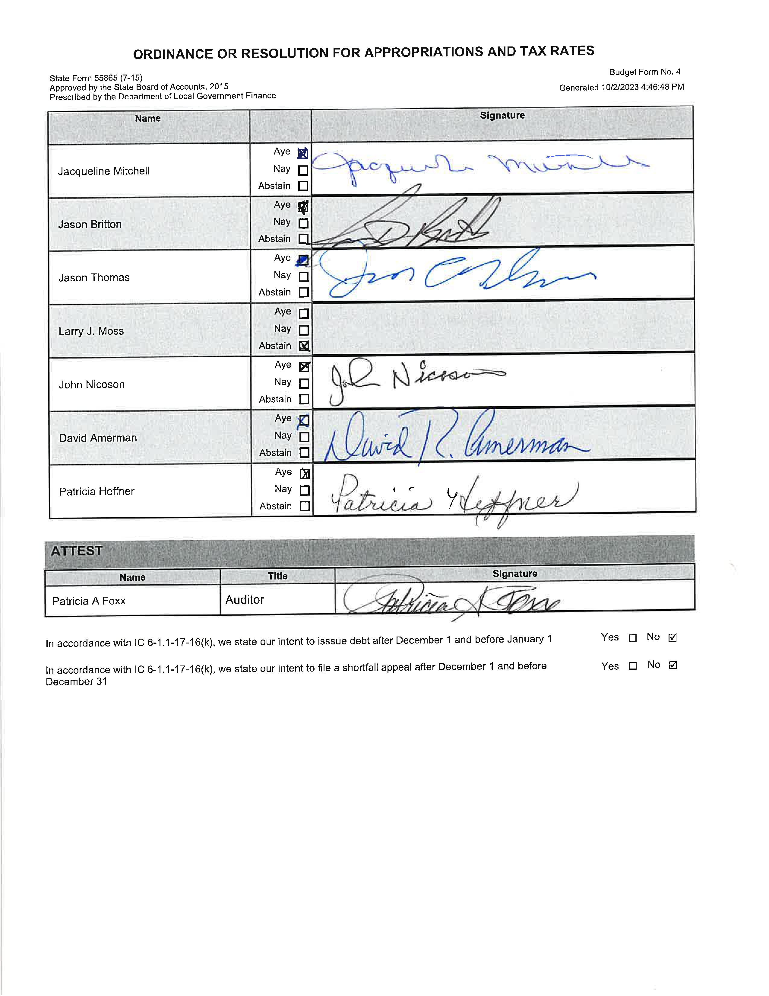

Motion to approve all 5 budget ordinances as presented was made by Jackie Mitchell and seconded by Jason Britton. Motion carried 6-0.

IN THE MATTER OF PUBLIC COMMENTS

No public comments.

IN THE MATTER OF ADJOURNMENT

There being no further business, John Nicoson made a motion to adjourn and seconded by Dave Amerman. Motion carried 6-0.

Members of the Clay County Council

Attest:

Patricia A Foxx, Clay County Auditor

